PUBLIC NOTICE
Rim Country Educational Alliance
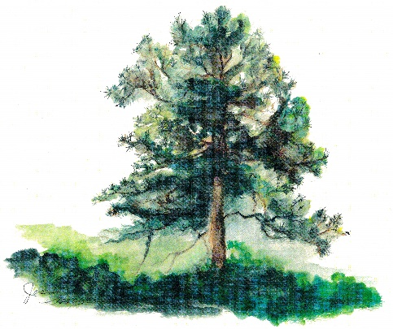
Annual Board Meeting
scheduled for June 11, 2026, is
Rescheduled for
June 18, 2026 @ 1:30pm

