PUBLIC NOTICE
Rim Country Educational Alliance
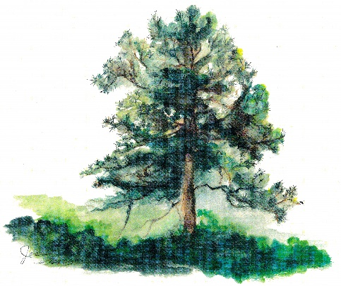
Regular Board Meeting scheduled for March 13, 2025, is
Rescheduled for
March 14, 2025 @ 1:30pm

