PUBLIC NOTICE
Rim Country Educational Alliance
THERE IS THE POSSIBILITY THAT A QUORUM OF THE Rim Country Educational Alliance (RCEA) Board of Directors WILL BE PRESENT DURING THE FOLLOWING SCHEDULED EVENT:

DATE: August 12, 2026

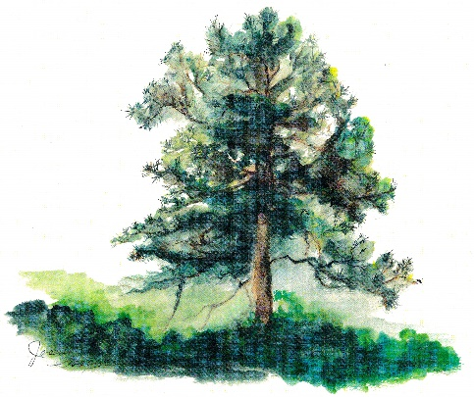
TIME: 10:00 A.M. to 12:00 P.M.

PLACE: Future Tonto Rim Search & Rescue Regional
Training and Operations Center
1100 E. Granite Dells Rd.

PURPOSE: Groundbreaking Ceremony

NO ACTION WILL BE PROPOSED OR TAKEN AND
NO RCEA BOARD BUSINESS WILL BE CONDUCTED

